**Problem 1. Building an ER model from Database Schema**

1. Finding Entities, key Attributes and related Attributes

* Customers

+ Key attributes: **customerid**

+ Related attributes: fullname, address, phone, birthday, sale, registrationdate.

* Staff

+ Key attributes: **staffid**

+ Related attributes: fullname, dayofentry, phone

* Products

+ Key attributes: **productid**

+ Related attributes: productname, unit, nation, price

* Invoice

+ Key attributes: **invoiceid**

+ Related attributes: purchasedate, customerid, staffid, value

* Detailofinvoice

+ Key attributes: **invoiceid, productid**

+ Related attributes: quantity

1. Finding Relationships

* Customers - Invoice:

+ One to many

* Staff - Invoice:

+ One to many

* Invoice - Detailofinvoice:

+ One to one

* Product - Detailofinvoice

+ One to many

1. Finding weak Entities and weak Relationships

* Weak entities: Detailofinvoice
* Weak relationships: Product – Detailofinvoice, Invoice - Detailofinvoice

1. Draw an ER model

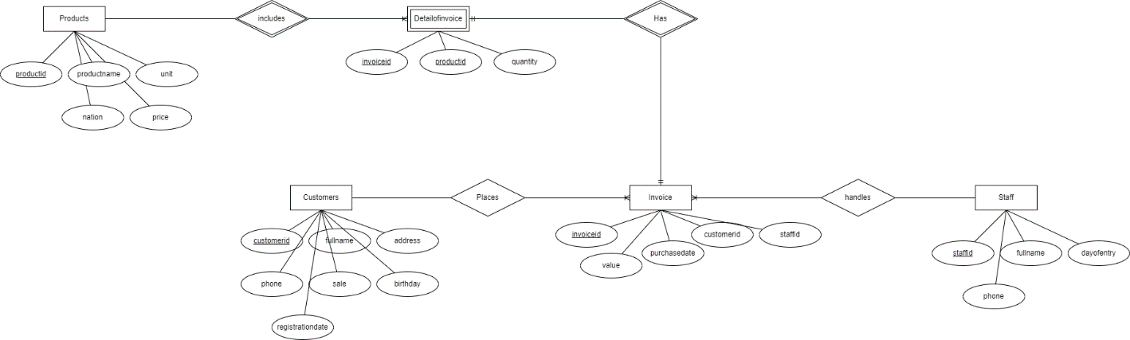

**Problem 2: Draw ER Diagram**

1. Finding Entities, key Attributes and related Attributes

* Employee

+ Key attributes: Employee code

+ Related attributes: fullname, dateofbirth, address, gender, managercode, departmentcode, salarytype

* Department

+ Key attributes: departmentcode

+ Related attributes: roomname, managercode

* Location
* Project

+ Key attributes: projectcode

+ Related attributes: projectname, location, departmentcode

* Relative

+ Related attributes: name, dateofbirth, relationship

1. Finding Relationships

* Manages:

+ Employee – Employee

+ Self-referencing

* Manages:

+ Department - Employee

+ One to many

* Has:

+ Department - Location

+ One to many

* Manages:

+ Department – Project

+ One to many

* Participate in

+ Employee – Project

+ Many to many

* Has

+ Employee – Relative

+ One to many

1. Finding weak Entities and weak Relationships

* Weak entity: relative
* Weak relationship: Employee - Relative

1. Draw an ER model

